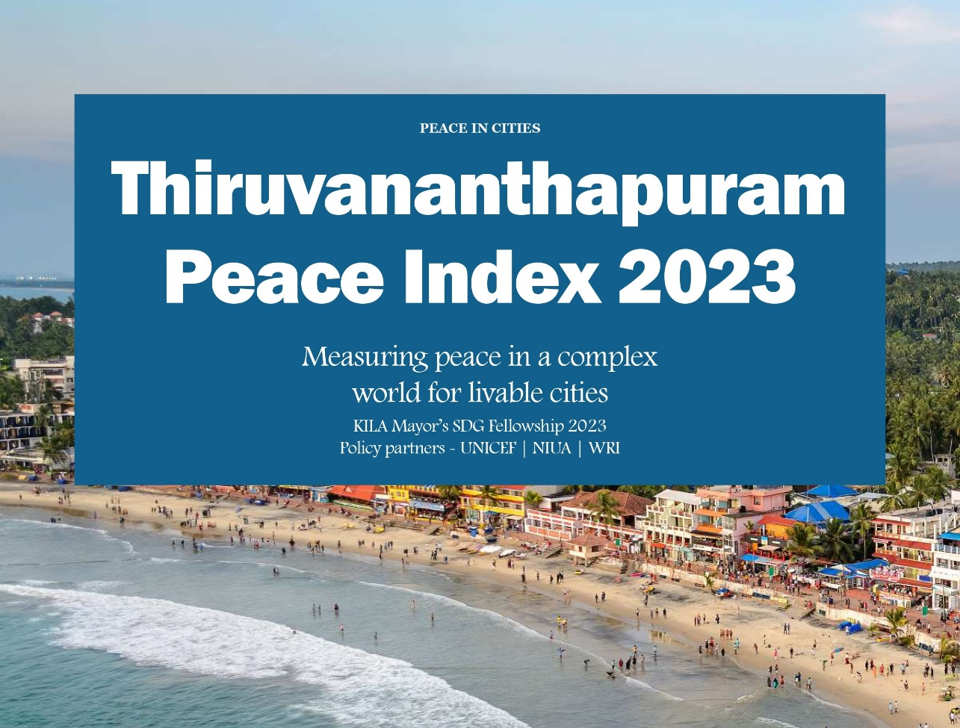
Title
Front Image

Measuring Peace, Shaping Livable Cities: Research Featured in Planning Times
Atharvi Netragaonkar
Architect & Urban Planner

Thiruvananthapuram Peace Index 2023
Measuring peace in a complex world for livable cities.

by Atharvi Netragaonkar | Published on: October 2023 | Publication: Planning Times

The capital city of the state of Kerala, Thiruvananthapuram has been
Declared as India’s very first peace city. The city has been identified to be one of its kind in the country not because of it being a place for unrest, but because it carries a strong lineage of peaceful coexistence of its people.
Peace has been the global agenda for nations to build better places of tomorrow, acknowledging the damage done in areas of un-rest is far more than just physical damage. Peace is an overarching theme that underpins the common vision of a life of dignity and well-being for all. In the rapidly polarizing world post Covid-19, the rationale behind incorporating the agenda for peace building and equality in Thiruvananthapuram is to create a “Just” city. A just city is where the dignity and rights of the citizens are taken care of and an environment that is socially and economically just for all its citizen is offered.
“PEACE MEANS DIGNITY, WELL-BEING FOR ALL, NOT JUST ABSENCE OF WAR”
Historically, the region was amongst the first to enjoy peaceful relation with the East India Company. Following which, there were many social infrastructural amenities built and social reforms that broke the caste system were taken place. Post-independence, the
State’s socialist ideologies have increased the quality of life and continue to do so. The state was one of the first in the country to incorporate decentralized planning with divulged funds, functions, and functionaries to the local bodies both in rural and urban areas. Trivandrum being the capital, has been a stage for the democratic expression of public frustration against an unresponsive state or its institutions through marches, events, and strikes. A peaceful and just city can facilitate active participation that will be an impetus to the decentralized governance. This people’s planning process has been synonymous with political participation of the people in exercising their democratic rights like freedom of expression.
Developing a Peace Index at the city level will not only help in decentralizing the vision but also will help in spreading the identity of the peace city and reaching out to a larger mass. The index would be helped in rating each ward in the Municipal Corporation boundary and develop a healthy competition in order to excel as an entire city holistically. To furthermore strengthen this idea of the index we contextualize the definition of peace. What is peace for the people of Thiruvananthapuram and therefore develop indicators according to the definition.
The vision for the city is to make Thiruvananthapuram, a city of peace spatially as well as non-spatially within the next 10 years.

About the city
The city of Thiruvananthapuram, the administrative capital of Kerala is amongst the top 3 in the National SDG ranking.
Area - 215 sq. km Population – 9, 55,494 Sex Ratio – 1040
No. of Wards – 100 Literacy – 94%

Considerations and Methodology
The measurement of peace is one of the major global agendas which eventually affect the wellbeing of people. To further understand its relevance and achieve the goal, decentralized planning mechanisms help a lot.
Peace can be categorized under two domains. Negative peace and positive peace.
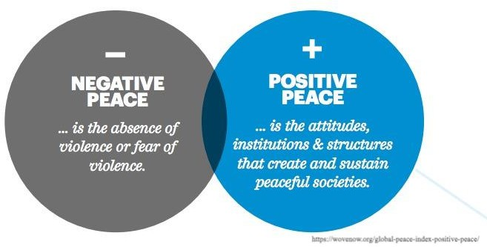

Image: Definition of peace; Source: Global piece index
Negative peace is defined as the absence of violence or absence of fear of violence. Peace is further not just restricted to that. Positive peace therefore is considered in a further nuanced definition which helps in somewhat capturing the intangible aspect of the term. Well-developed Positive Peace represents the capacity for a society to meet the needs of its citizens, reduce the number of grievances that arise and resolve remaining disagreements without the use of violence.
Considering this, there must be a contextual process of tweaking the definition of peace in the city of Thiruvananthapuram, to further understand what is peace for the people here. Thus, to do so, we ask the 100 ward councilors, who are democratically elected and represent the people of the city
CASE STUDY 1 _ MLA_ Mr. V K Prashant (Ex Mayor)
“Peace is eventually related to building a livable city. Peace and livability of any city is directly proportional to each other. The effort can be thus in improving the health of the city and making the city more desirable for living.”
The process of understanding peace for Vattiyoorkavu ward was to take randomly sampled interviews of the people of the ward. The questions were asked in order to understand if the idea of peace is relative or common for the people of the city.
Such interviews need to be conducted in all the 100 wards to establish a holistic definition of contextual peace. Once we have responses on what defines peace, formulation of indicators and data collection by concerned authorities can start.
Positive Peace is a state of mind of an individual and thus on a macro level, the people of the city. On a global scale the following factors affect the state of mind.
- State of jobs and opportunities
- State of Health (physical and mental)
- Having someone to count on
- Social Security
- State of vulnerable.
- The state of good governance
Once the factors affecting peace of the city and its people are in place through questionnaire circulation within the 100 ward councilors, Data collection from the people can start through the process of sampling. The 100 wards can be thus rated based on these indicators.
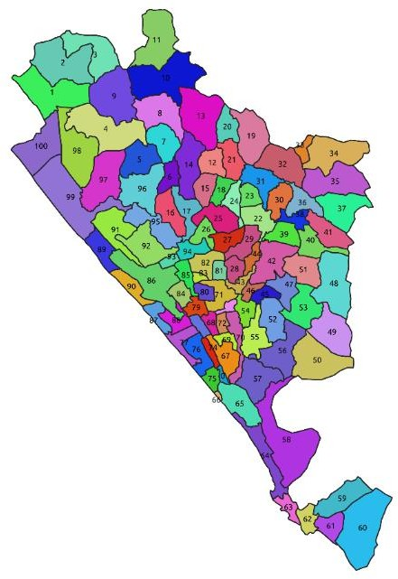

Image: A visual representation of ward wise map of Thiruvananthapuram Municipal Corporation for probable TPI representation; Source: Author

SDG 16 Indicators
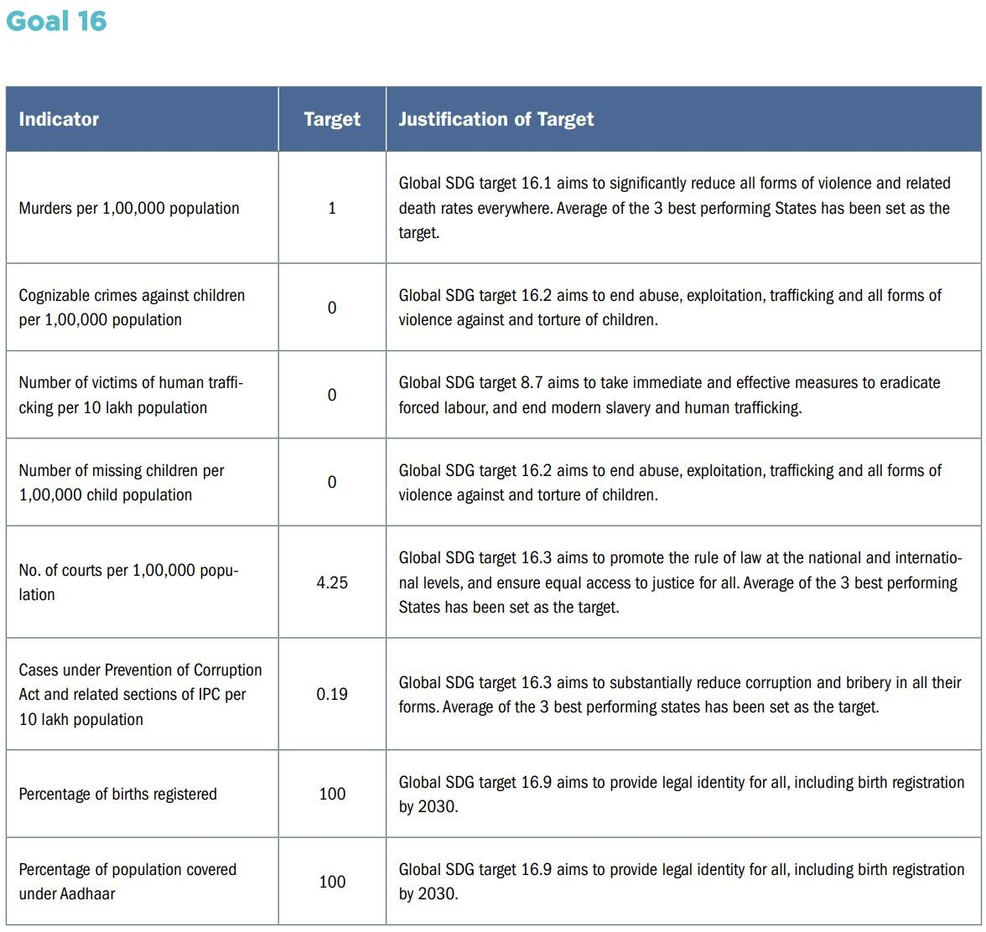
The following are the indicators used for the national peace and social justice while considering the sustainable development goal.

Image: SDG Goal 16 Indicators; Source: UN SDG Goals

Way Forward
Once according to the people of Trivandrum the final defining peace parameters are included in the list, indicators which can be used as a measuring tool or as a proxy to quantify the parameters can be identified. The data collection according to the indicators with concerned departments can be looked up by either the planning cell or the peace city cell. Once the index is consolidated, each ward can be given a rank based on its performance.

The analysis of this will not help people understand the performance of their own ward but also will act as a people’s progress card where the community would start developing a sense of ownership to the idea and identity of peace. Annual release and updating of this index and data will result in the overall growth and further will nurture the identity of
India’s first peace city.

